IoT Vehicle Sensing Platform

Kevin Rivera

ELE 547

Final project pre-proposal

***Proposal description***

This proposal consists of three major components which are a vehicle sensing platform, data hub/IoT hub/controller also called the hub, and a webserver to display video footage and sensor data (Fig. 1).

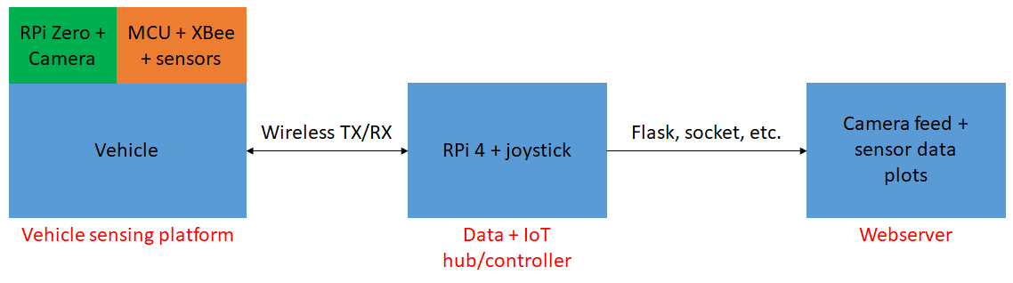

*Fig. 1*: Connection diagram of the proposed final project.

***Functionalities and features***

The vehicle sensing platform is composed of an MCU controlled vehicle that receives directional information from the hub via XBee, environmental sensors that will be used to collect data on local conditions and a Raspberry Pi Zero W which will be interfaced with a camera to gain a first person perspective of the vehicle. The environmental sensor data and camera footage will be sent to the hub.

The hub consists of a Raspberry Pi 4 connected to a sense hat. The joystick on the sense hat will be used to send directional inputs to the vehicle via XBee. The data that is sent to the hub is then uploaded to a local webserver.

Finally, the webserver will contain video footage from the Raspberry Pi Zero W, and also real-time plots displaying the environmental sensor data collected.

***Previous work related to this proposal***

This project is inspired by a game that was recently released by Nintendo called “Mario Kart Live: Home Circuit”. In this game, the user can take control of a remote control (RC) car from their game console. The toy car is equipped with a camera that feeds live first person view footage to the users game console screen. The screen also has a built in UI showing the toy car speed, map layout, items, etc. and also uses object recognition to identify cardboard gates and walls that are included with the game.

***Aspects unique to this project***

This project will utilize a vehicle known as “Rover V2” which is a tank instead of a race car. The vehicle will be outfitted with sensors to gather environmental information and also collision avoidance sensors that will give the vehicle the ability to temporarily override directional commands. The vehicle will also have provide live first person footage but it will come from a Raspberry Pi Zero + Pi camera setup. The vehicle and controller will also utilize XBee to communicate sensor readings and directional commands to each other respectively. Lastly, Object recognition may also be implemented to potentially identify signs, lights, etc.

***Resource requirements and availability***

|  |  |
| --- | --- |
| Item needed | Status |
| Rover V2 | On route |
| Raspberry Pi Zero | Available |
| Raspberry Pi Camera | On route |
| Sensors (gas, temp, humidity, etc.) | On route |
| XBee transceivers | Available |
| Raspberry Pi 4 | Available |
| Joystick (Sense hat) | Available |
| MCU (Teensy 4.0 or Atmega328P) | Available |

***Definition of project success***

The project will be considered successful if the following are accomplished: A vehicle with environmental sensors is setup, wireless communication is established between all parts of the project, a local webserver showing first person footage and sensor data plots is established, and object recognition is implemented if possible.

***Weekly deliverables***

|  |  |
| --- | --- |
| Date | Deliverable |
| 11/02/2020 – 11/08/2020 | Setup vehicle and XBee communication. Make a basic controller to test vehicle movement. Setup camera with RPi Zero W. |
| 11/09/2020 – 11/15/2020 | Interface sensors with the MCU and setup XBee sensor data transfer to the RPi 4. Setup webserver to display sensor data and/or plots. |
| 11/16/2020 – 11/22/2020 | Display camera feed on webserver. Achieve first person control on the vehicle. Test XBee range. |
| 11/23/2020 – 11/29/2020 | Incorporate the collision avoidance aspect of the project and test in first person view. Combine data collection/plotting and vehicle controlling. |
| 11/30/2020 – 12/06/2020 | Combine all the parts of project (vehicle, IoT hub/controller and webserver) and workout the any last minute bugs. 3D print any structural parts. |